# Unity Basics

In this lesson students learn about Unity’s interface and GameObjects. Students will create a GameObject, add a material, and transform it.

## Objective

Students will be able to:

* Navigate Unity’s user interface
* Create a GameObject
* Add material to a GameObject
* Use transform to manipulate a GameObject

[Navigating Unity's Interface](https://youtu.be/kq-H4Pligbg)

Example: [3D Objects and Scene Navigation](https://youtu.be/RFpbbnNh9A0)

## Make a Pyramid

Over the course of this lesson, you will construct a colorful pyramid. In this activity, you will complete the first step, making the pyramid!

To start, open the Unity Hub and select the Project tab. Under the projects, click ‘New’, choose 3D, and then name your project “Pyramid - [YOUR NAME]”. It’s important you include your name so that your teacher can identify your project!

Create a pyramid that has three cubes on the bottom, two cylinders on the second row, and a sphere on top. It doesn't matter where in space your pyramid is, but it should end up looking something like this:

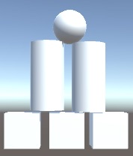

Once you have shared your project, answer the following questions:

1. What is the name of the project you shared?
2. What was challenging about this exercise? How did you overcome the challenge?
3. You have now mastered a new Unity skill! How can you imagine using any of these 3D objects in a future game?

Example: [Adding Material to a GameObject](https://youtu.be/-a7gAluCLq8)

## Color Your Pyramid

Add three new material assets to your project, and apply these materials to your pyramid. Take this opportunity to play around with the metallic and smoothness levels!

Your pyramid should end up looking something like the image below, although the materials you choose may be different.

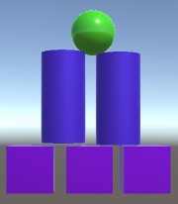

As a reminder, you will need to create a Materials folder inside the Assets folder before you begin making materials.

1. What visual impact do metallic and smoothness levels have on a material?

Example: [Transforming GameObjects](https://youtu.be/SjRQqmtDnrQ)

## Transform Your Pyramid

In this activity, you will practice using the transformation tools to change the size and position of your pyramid objects. You can use the Transform component or the tools in the toolbar - whichever you find easier.

* Change the height of the cylinders so that they are shorter.
* Rotate the cubes 45 degrees around the Z-axis.
* Ensure the Y coordinate for all of the GameObjects in a row is exactly the same.

Your pyramid should end up looking similar to the image below:

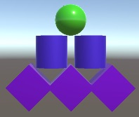

Helpful Hints:

* You can manipulate the values of multiple GameObjects at the same time by left-clicking and dragging your mouse to create a rectangle that encompasses the GameObjects you want to select. See the Unity Manual page [here](https://docs.unity3d.com/Manual/ScenePicking.html).
* You can use the keyboard shortcuts to easily switch between the Scene View and GameObject tools:
  + W: Move tool
  + E: Rotate tool
  + R: Scale tool
  + T: Rect tool

1. How did you use the toolbar tools and the Transform component to complete the tasks? Do you prefer one method over the other? Why?